NEXTAG COMPANY

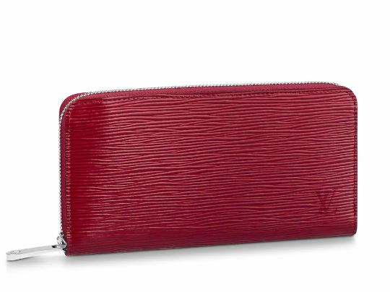LOUIS VUITTON - ZIPPY WALLET

##### **Detail**

The Zippy wallet is crafted from Epi leather, characterized by its distinctive grain. One of Louis Vuitton's most iconic models, the Zippy wallet is named for its secure, all-round zip, which opens to reveal multiple card slots, pockets and compartments. Perfect for organizing everyday essentials, this wallet can also be used as a clutch.

• Cherry Berry Burgundy

• Epi grained cowhide leather

• Grained cowhide-leather lining

• Silver-color hardware

• 3 large gusseted compartments

• 19.5 x 10.5 x 2.5 cm (Length x Height x Width)

##### **CARE & COMPOSITION**

* leather
* imported